Lab 02

Title:
Basic Syntax, Input/Output, Data Types & Arithmetic Operations in C++
Objective:
To understand the basic structure of a C++ program, perform input/output operations, use different data types, and apply arithmetic operators.
Theory:
Basic Syntax of C++
A c++ program follows a specific structure:

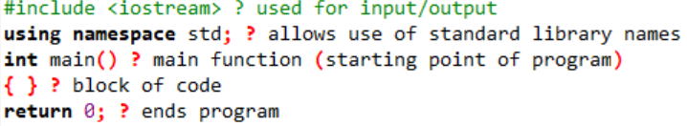
Input and Output in C++
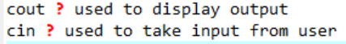
Example:
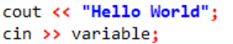
Data Types in C++
Data types define the type of data a variable can store:
- Data Type
- Description
Example
- Int
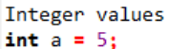

- Float

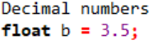
- Double
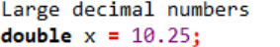
- Char
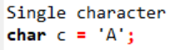
- String
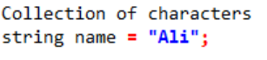
Arithmetic Operators
Used to perform mathematical operations:
- Operator
- Meaning
Example
- +

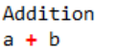

- -
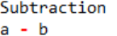
- *
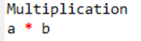
- /
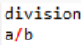
- %
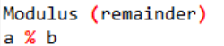
Program:
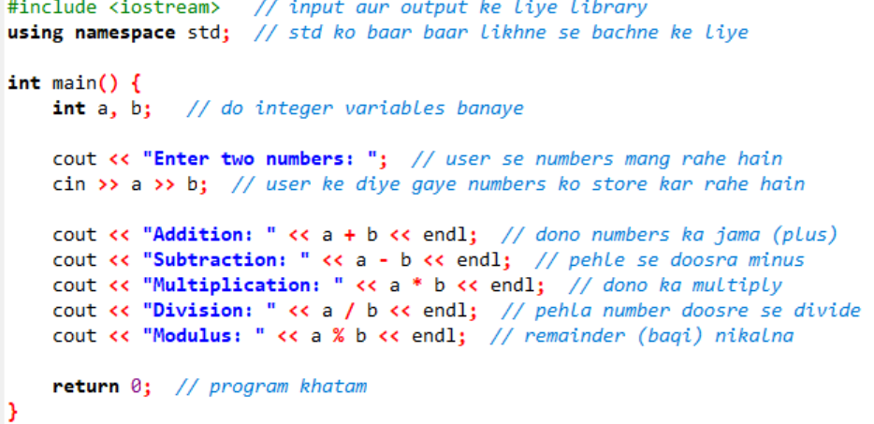
Explanation:
- Two integers a and b are declared.
- User inputs values using cin.
- Arithmetic operations are performed.
- Results are displayed using cout.
Sample Output:
Enter two numbers: 10 5
Addition: 15
Subtraction: 5
Multiplication: 50
Division: 2
Modulus: 0
Conclusion:
In this lab, we learned:
- Structure of a C++ program
- How to take input and display output
- Different data types
- Use of arithmetic operators
Lab tasks

(1):Declare a different type of variables and find its memory,size,location and values
Code:
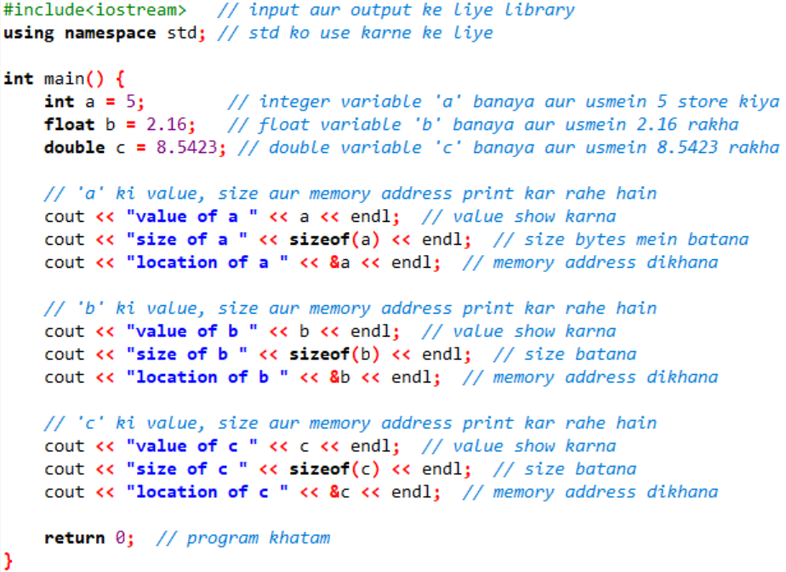

(2):Write a c++program that converts temperature from Celsius to Farenhit
Code:
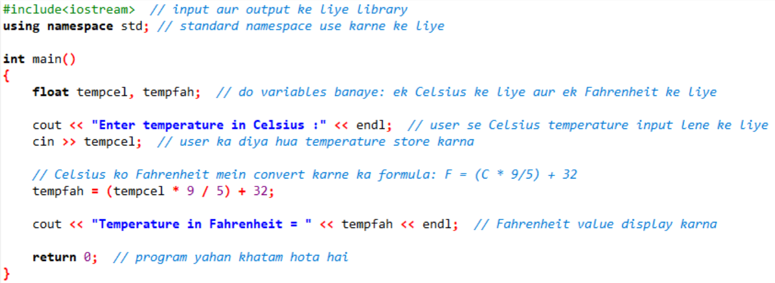

(3):Write a c++ program that declare and display a floating point variables called “pi” And assign it the value 3.14
Code:
